Army/COS/14/9/1

3 Sep 14

See Distribution

frago 01 to OpO 14/002 – THE ARMY’S APPROACH TO ‘RISK TO LIFE’
SPORT AND ADVENTUROUS TRAINING

Reference:

A. Army/COS/14/2/10 dated 28 Feb 14.

SITUATION

- This FRAGO is issued in accordance with Reference A and prior to the publication of a revised LFSO 3216 that will detail the Army’s mechanism for complying with its Duty Holding (DH) responsibilities. As a result of the complexity that surrounds the governance of sport and Adventure Training (AT) in the Army, there is a need to articulate specific measures in order to keep the risk inherent in these Risk to Life (RtL) activities, to As Low as Reasonably Practicable (ALARP), at all levels. It is essential that the application of DH does not impede the participation by all ranks in sport and AT. This FRAGO only applies to sport and AT conducted on duty.

MISSION

- The Chain of Command is to conduct activities safely within its areas of responsibility in order to ensure the safety of the entire workforce (military and civilian) whilst maintaining operational output so far as is reasonably practicable.

EXECUTION

- Concept of Operations. See schematics at Annexes A -D.
  - Intent. No change.
  - Scheme of Manoeuvre.
    - Sport. The OPCOM DH Chain of Command retains responsibility, accountability and authority (RA2) for the authorisation of soldiers’ participation in sport through publication of names on Part One Orders. The Army Sports Control Board (ASCB) retains RA2 for duty of care within sporting events. Sports secretaries provide direction on the safe conduct and governance of specific events, in line with clear rules and regulations. Event organisers issue instructions and manage arrangements for their events, in line with direction received, and confirm compliance back to respective sports secretaries. These instructions must provide the relevant detail to enable COs to authorise ‘On Duty’ participation of their soldiers before their names are entered onto Unit Part One Orders. In the case that COs, as Delivery Duty Holders (DDH), have concerns over the risk management for an event they should, in the first instance, seek further assurance from the event organiser. If still dissatisfied they should then apply to the relevant sports secretary. DTrg, as the ACA&I for sport, will institute a formal inspection and assurance regime that will target the organisation and arrangements of sports events to ensure risk is being managed appropriately. The importance of the event instruction, which includes an appropriate risk assessment cannot be overstated as it is the receipt and examination of this document by the CO that allows him to form a judgement as to whether, as the DDH, that risk is at ALARP and tolerable to him.
    - AT. Similar principles apply to AT. Joining instructions for formal courses and exercise instructions for Joint Service Adventurous Training Form Alpha (JSATFA) and Unit Authorised Adventurous Training (UAAT) based AT must clearly nominate the DDH for the activity (including times of transfer between DDHs), compliance with the Safe System of Training and reference to the authoritative policy documents that endorses the activity. AT activities undertaken within Joint Force Command (JFC) apply DH principles in accordance with the JFC DH construct.
  - Main Effort. No change.
- Tasks.
  - CGS (as Senior Duty Holder (SDH)). No change.
  - CLF, AG, Comd FD&Cap (providing 3* oversight). No change.
  - GOC 1 (UK) Div, GOC 3 (UK) Div, Comd JHC, GOC FTC, GOC LONDIST, GOC Sp Comd, DG ART, Comdt RMAS, DG Cap (as Operating Duty Holders (ODH)). No change.
  - 1*/OF 5 Commanders (providing 1* oversight). No change.
  - Commanding Officers/County Commandants/OCs of Independent Squadrons (as DDH). After conducting due diligence, authorise ‘on duty’ status for soldiers participating in sport and AT through inclusion on Part One Orders.
  - DG Cap (as the DH-facing SME). No change.
  - ATG(A), Sp Comd Desk Officers, Trg Offr ATFD (Sennelager), OC JSPC(N), DSEA SoD, SO2 PD LONDIST, SO2 AT BATUK, SO2 PD BATUS (as DH-facing SME). Advise DDH/ODH on acceptance of risk for AT.
  - CESO(A). No change.
  - Chief Engineer (Army). No change.
  - COS AG. AG is to direct ASCB, in accordance with its Charter, to ensure that sport in the Army is conducted, governed and executed in compliance with Service, NGB, ASCB and CSSB regulations.
  - Sports Secretaries.
    - Provide direction on the conduct and governance of events for their specific sports in line with NGB/CSSB/ASCB rules and regulations.
    - Maintain, through audit of compliance, the duty of care chain through to event organisers.

  - Sporting Event Organisers.
    - In conjunction with appointed sports officials ensure there is a duty of care at sporting events that brings all inherent risks to ALARP.
    - Issue an event instruction that includes a risk assessment with clear measures to mitigate risk.
    - Advise DDHs on risk mitigation measures within an event to assist them in conducting due diligence.
    - Exercising risk mitigation measures to ensure tolerability for DDHs.
    - Provide evidence of compliance of the event with NGB/CSSB/ASCB regulations.
- Coordinating Instructions.
  - Assurance. D(Trg) will assure the safe management of sport and AT as the Army Competent Adviser and Inspector (ACA&I).
  - Additional stakeholders in sport:
    - National Governing Bodies (NGB). The NGBs provide the regulations and governance of a sporting activity through the publication of their rules and regulations; all sport in the Army is played in accordance with NGB regulations.
    - Combined Services Sports Board (CSSB). The CSSB is responsible for promoting, developing and providing policy direction on the conduct of sport within and between the three Services and at UK Armed Forces level in accordance with its Charter.
  - Additional stakeholders in AT:
    - CJO.
    - CBFSAI.
    - CBF Gibraltar.
    - CBF Cyprus.

SERVICE SUPPORT

- No change.

COMMAND AND SIGNAL

- No change.

Authorise. | Acknowledge.
TR URCH | JCC SCHUTE
Maj Gen | Col
COS LF | CESO(A)
Annexes:

- DH and Sport. The duty of care, governance and assurance process for all sport conducted in the Army.

- DH on AT – Formal Course Delivery. The governance and assurance process for the delivery of AT activities and training through ARTD.

- DH on AT – JSATFA based and UAAT. The governance and assurance process for AT activities delivered at unit level (UK and overseas).

- DH on AT – Army AT within JFC. The governance and assurance process for AT conducted by Army personnel within JFC.

Distribution:

MA1/CGS
MA/CLF
MA/AG
MA/Comd FD&Cap
GOC 1 (UK) Div
GOC 3 (UK) Div
Comd JHC
GOC FTC
GOC Sp Comd
GOC LONDIST
Comd RMAS
COS FD&Cap
COS AG
Army Inspector
CESO(A)
Chief Engineer (Army)

Copy to:

GOC SCOTLAND
GOC BFG
ACGS
DCLF
DASCB
COS JFC
COS Ops PJHQ
DG Pers
D DSEA
Comd 38 (Irish) Bde
D Plans
ACOS LF
ACOS Ops
ACOS Res & Cdts LF
BMC(A)
DTrg

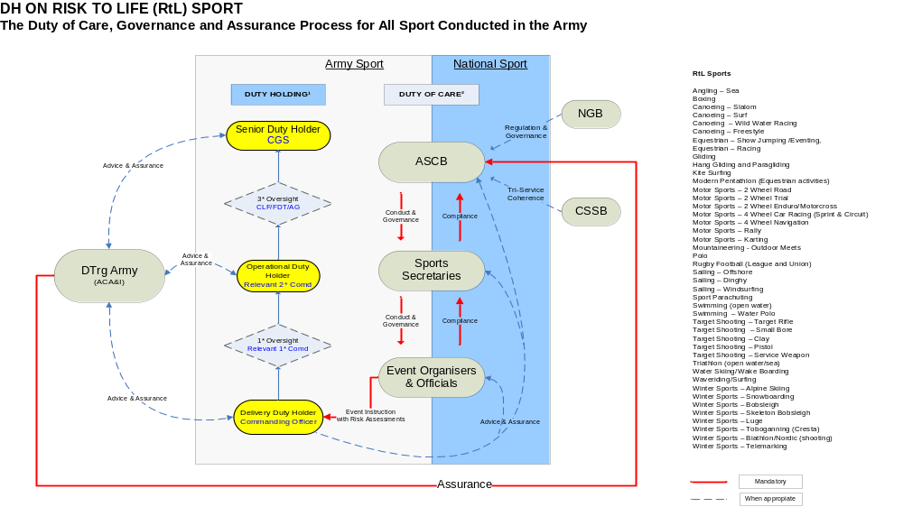
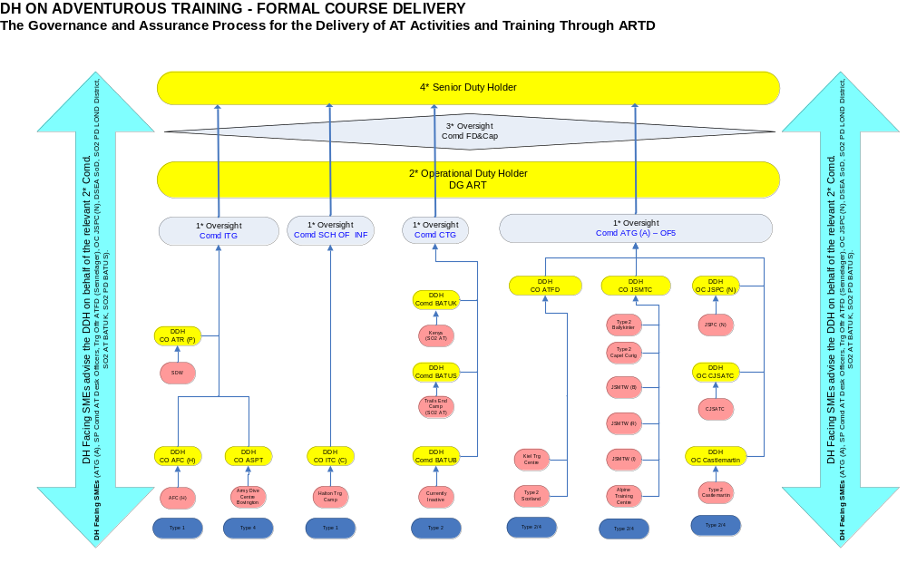
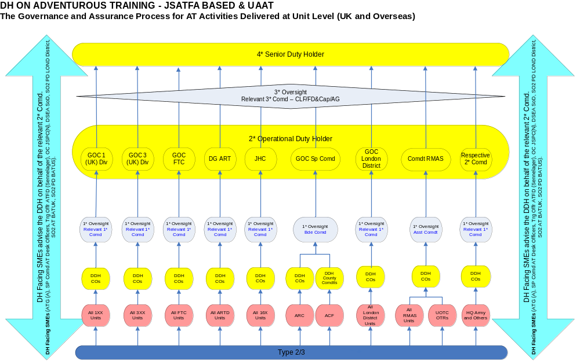
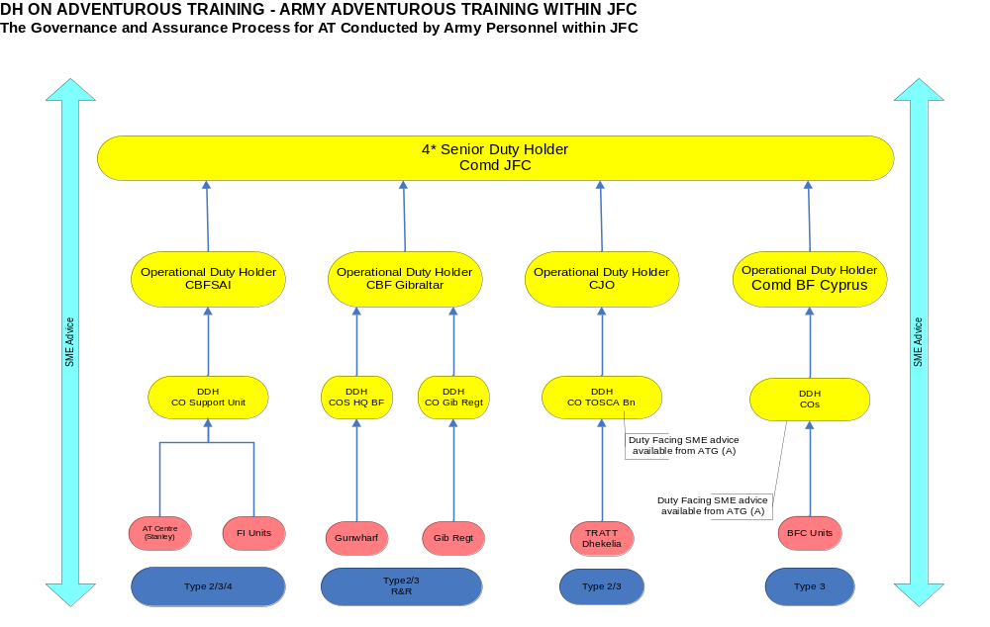

Training, events and competitions.
Those sports that are ‘in scope’ are at Annex A.
Individual, Elite, Unit, Formation, Leagues/Competitions, Corps, Army and Combined Services.
Soldiers are deemed on duty when their names appear on Part One orders. Soldiers may participate in sport and AT when off duty but are participating in a private capacity, attract no MoD liability and are not protected by HASWA 74.
So meeting the Army’s obligations to HASWA 74.
As supplied by NGBs, ASCB or CSSB.
The process for authorising expeditions both in the UK and overseas.
AT that is conducted at unit level to aid with continuation training without the requirement of a JSATFA.
For Trials and Development units.
AGAI Vol 1 Ch 5 – Appendix 2 to Annex E.
Sports secretaries are either employees of the ASCB or serving personnel within the Army and are all Crown servants.
These are individuals, both military and civilian, charged with organising sporting events.
A computation must be made by the owner in which the quantum of risk is placed on one scale and the sacrifice involved in the measures necessary for averting the risk. HSE Guidance http://www.hse.gov.uk/risk/theory/alarpglance.htm refers.
AGAI Vol 1, Chap 5 & 11.

