ARU Corps Contact Details
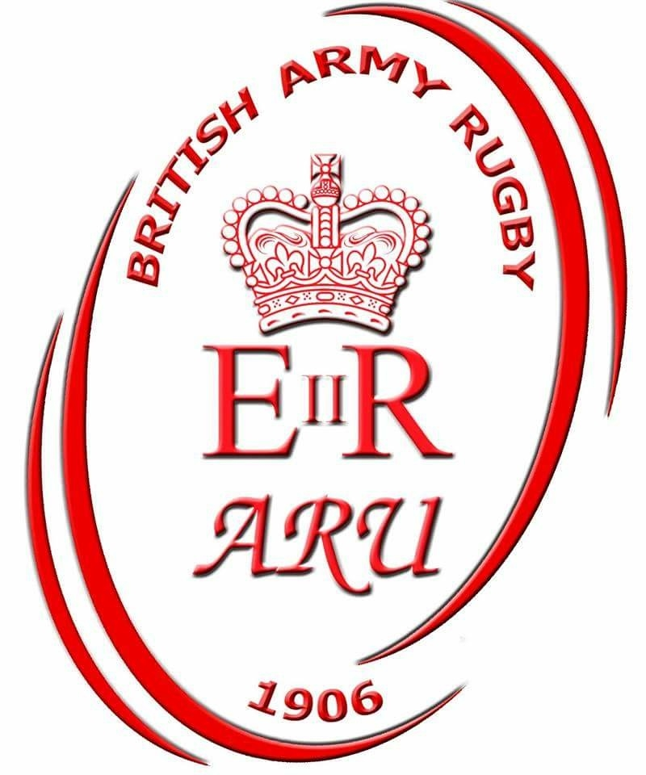
Director Community |  | Jason Gunning (07967 832 612) |  | APC-ComdSp-RSIGNALS-Offr-SO1@mod.uk
Chair Corps |  | Nick Andrew (07721 777207) |  | FdArmy-Warfare-Coord-DACOS@mod.uk
Sec Corps (Men) |  | Richie Crane (07902 182393) |  | 29RLC-RHQ-RCMO@mod.uk
Sec Corps (Women) |  | Jules Simpson (07753 271702) |  | ATCP-1ATR-RHQ-RSM@mod.uk
Secretary ARU |  | Chris Fowke (07595 116118) |  | cfowke@ascb.uk.com
RDO |  | Taff Bamsey (07766 557546) |  | taffbamz@yahoo.co.uk
Director Fin ARU |  | Tony King (01252 787083) |  | aking@ascb.uk.com
Officials appointing |  | Martin Bentley (07854 902614) |  | 7RLC-LAD-ASM@mod.uk
Coaching training |  | Richard Garrett |  | richard.garrett983@mod.uk
Corps Primary Contact Details
 | Name |  | Email |  | Home Ground
L1
RLC | Rob Futter  (03067 981189) |  | 29RLC-RHQ-2IC |  | Hullavington
INF | John McCallum  (07850 327171) |  | 1SG-HQ-QM |  | Pirbright
RA | Andy Taylor  (07974 346707) |  | 32RA-RHQ-2IC |  | Larkhill
RE | Taff Smith  (01252 863536) |  | 8ENGRX-G3-SO3-UKOPS |  | Minley / Chatham
REME | Andy Franklin  (07766406852) |  | 6REME-BnHQ-ESOps-BTO |  | Royal Wootten Bassett RFC
R SIGS | Matt Wray  (01225 814099) |  | 21SIG-220-OPS-OFFR |  | Stafford RFC
L2
AAC | Alan Adamson  (02894 455716) |  | ALG-JSU-QM |  | Middle Wallop
AMS | Hywel James  (07875 752827) |  | RCDM-Clin-MilitaryNO-04 |  | Keogh Barracks
INT | Mark Booth  (07854 318467) |  | mark.booth104@mod.uk |  | Chicksands
RAC | Lee Cummings  (01929 403332) |  | ARMCEN-DM-COMBAT-CR2-WO |  | Bovington
RAPTC | Luke Brimble (01980652748) |  | 1RHA-OHQBTY-QMSI |  | Aldershot
AGC | Jaimie O’Mara  (02392 284656) |  | DSPG-HQ-DCOS |  | Southwick Park

Date | Men Corps League 1 |  |  |  | Men Corps League 2
Festival  Wed 14 Sep 16 | 15 a-side competition |  |  |  | 10 a-side competition
Corps 1  Wed 28 Sep 16 | REME |  | RE |  | RAC |  | AAC
Corps 1  Wed 28 Sep 16 | RLC |  | INF |  | AGC |  | RAPTC
Corps 1  Wed 28 Sep 16 | RA |  | RSIGS |  | AMS |  | INT
Corps 2  Wed 12 Oct 16 | RSIGS |  | REME |  | RAC |  | AMS
Corps 2  Wed 12 Oct 16 | RE |  | RLC |  | RAPTC |  | AAC
Corps 2  Wed 12 Oct 16 | RA |  | INF |  | INT |  | AGC
Men Corps 3  Wed 9 Nov 16 | REME |  | RA |  | INT |  | RAC
Men Corps 3  Wed 9 Nov 16 | RLC |  | RSIGS |  | AMS |  | RAPTC
Men Corps 3  Wed 9 Nov 16 | RE |  | INF |  | AAC |  | AGC
Men Corps 4  Wed 7 Dec 17 | RLC |  | RA |  | AGC |  | RAC
Men Corps 4  Wed 7 Dec 17 | INF |  | REME |  | RAPTC |  | INT
Men Corps 4  Wed 7 Dec 17 | RSIGS |  | RE |  | AAC |  | AMS
Corps 5  Wed 25 Jan 17 | REME |  | RLC |  | RAC |  | RAPTC
Corps 5  Wed 25 Jan 17 | RA |  | RE |  | AGC |  | AMS
Corps 5  Wed 25 Jan 17 | INF |  | RSIGS |  | INT |  | AAC
Corps Finals
Wed 22 Feb 17
- All fixtures are at 1400 hrs on the day stated above unless authorised by Chair ARU Corps Rugby.
- HOME TEAMS ARE TO:
- Confirm fixture at least 7 days prior with Away team and Officials confirming location.
- Text (07721 777207) result to Chair ARU Corps immediately after final whistle informing score, no of tries by team and any red cards awarded (name and cap badge)
- Officials appointments can be found at http://www.armyrugbyunion.org.uk/aru-referees/referee-appointments/ All teams are encouraged to leave feedback on officials at http://www.armyrugbyunion.org.uk/aru-referees/referee-feedback/
- Rules and Regulations are at http://www.armyrugbyunion.org.uk/wp-content/uploads/2012/12/20160619_ARU-Corps-Mens-League-Regulations_16_17.doc
- ARU Corps website showing results is at http://www.armyrugbyunion.org.uk/competition/corps-championship/
- ARU Corps Facebook is at https://m.facebook.com/ARU-Corps-Rugby-450050735149993/

Date | Womens Corps League
Festival  Wed 14 Sep 16 | 10 a-side competition
Corps 1  Wed 28 Sep 16 | REME/RE |  | RSIGS/RA
Corps 1  Wed 28 Sep 16 | RLC |  | AGC
Corps 1  Wed 28 Sep 16 | AMS |  | RAF Dev
Corps 2  Wed 12 Oct 16 | RAF Dev |  | REME/RE
Corps 2  Wed 12 Oct 16 | AGC |  | RSIGS/RA
Corps 2  Wed 12 Oct 16 | AMS |  | RLC
Corps 3  Wed 09 Nov 16 | RSIGS/RA |  | AMS
Corps 3  Wed 09 Nov 16 | AGC |  | REME/RE
Corps 3  Wed 09 Nov 16 | RLC |  | RAF Dev
Corps 4  Wed 07 Dec 16 | RSIGS/RA |  | RLC
Corps 4  Wed 07 Dec 16 | REME/RE |  | AMS
Corps 4  Wed 07 Dec 16 | RAF Dev |  | AGC
Wed 25 Jan 17 | REME/RE |  | RLC
Wed 25 Jan 17 | RSIGS/RA |  | RAF Dev
Wed 25 Jan 17 | AGC |  | AMS
Corps Finals
Wed 22 Feb 17
- All fixtures are at 1400 hrs on the day stated above unless authorised by Chair ARU Corps Rugby.
- HOME TEAMS ARE TO:
- Confirm fixture at least 7 days prior with Away team and Officials confirming location.
- Text (07753 271702) result to Sec ARU Womens Corps immediately after final whistle informing score, no of tries by team and any red cards awarded (name and cap badge)
- Officials appointments can be found at http://www.armyrugbyunion.org.uk/aru-referees/referee-appointments/ All teams are encouraged to leave feedback on officials at http://www.armyrugbyunion.org.uk/aru-referees/referee-feedback/
- Rules and Regulations are at http://www.armyrugbyunion.org.uk/wp-content/uploads/2012/12/20160619_ARU-Corps-Mens-League-Regulations_16_17.doc
- ARU Corps website showing results is at http://www.armyrugbyunion.org.uk/competition/corps-championship/
- ARU Corps Facebook is at https://m.facebook.com/ARU-Corps-Rugby-450050735149993/

ARU Corps Contact Details
Director Community |  |  | Jason Gunning (07967 832 612) |  | APC-ComdSp-RSIGNALS-Offr-SO1@mod.uk
Chair Corps |  |  | Nick Andrew (07721 777207) |  | FdArmy-Warfare-Coord-DACOS@mod.uk
Sec Corps (Men) |  |  | Richie Crane (07902 182393) |  | 29RLC-RHQ-RCMO@mod.uk
Sec Corps (Women) |  |  | Julie Simpson (07753 271702) |  | julie.simpson452@mod.uk
Secretary ARU |  |  | Chris Fowke (07595 116118) |  | cfowke@ascb.uk.com
RDO |  |  | Taff Bamsey (07766 557546) |  | taffbamz@yahoo.co.uk
Director Fin ARU |  |  | Tony King (01252 787083) |  | aking@ascb.uk.com
Officials appointing |  |  | Martin Bentley (07854 902614) |  | 7RLC-LAD-ASM@mod.uk
Coaching training |  |  | Richard Garrett |  | richard.garrett983@mod.uk
Corps Primary Contact Details
Corps | Appointment | Name |  | Email/Mobile Number
AGC | Secretary | Maj Amie Powley-Williams |  | williamsamie@yahoo.co.uk 07540 434848
AGC | Manager | LCpl Nicole Bradshaw |  | Nicole.bradshaw101@mod.uk 07932 474290
AMS | Secretary | SSgt Leane Jones |  | 16Med-23-SQMS@mod.uk
AMS | Manager | Sgt Laura Thorley |  | 16MED-19-WardSNCO@mod.uk 07929 236136
RA | Secretary | Maj Andy Taylor |  | 32RA-RHQ-2IC@mod.uk 01980 845319
RA | Manager | Capt Erica Mills |  | RARHQ-Recruiting-Team-OC@mod.uk 07825411762
RE | Secretary | Capt Fran Bullock |  | RMAS-OC-ACI-PLANS@mod.uk 07891 580557
RE | Manager | See REME manager
REME | Secretary | Capt Andy Franklin |  | Andrew.Franklin939@mod.uk 07766406852
REME | Manager | Capt Steve Blanks |  | 105REME-BHQ-ROSO@mod.uk 07917 420534
RLC | Secretary | Lt Jade Binskin-Barnes |  | DLS-25RLC-109-OpsOffr@mod.uk
RLC | Manager | vacant
R Sigs | Secretary | Capt Matt Wray |  | 21SIG-220-OPS-OFFR@mod.uk 01225 814099
R Sigs | Manager | WO2 Matthew Turner |  | 3SR-206-SSM@mod.uk 01980 672306

