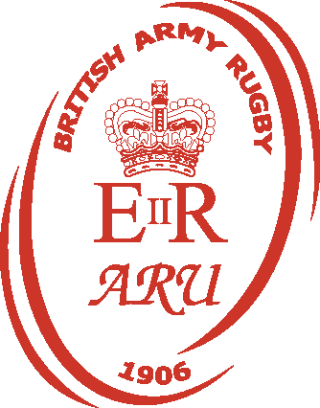
QTR Final  On 16 JAN | Semi Final  On 13 FEB | Final  On 20 March | WINNER
SDG
5 Scots
14 Sig Regt
2 MERCIAN
11 Sig Regt
39 Regt RA
33 Eng Regt
28 Eng Regt

