Chief of Defence People
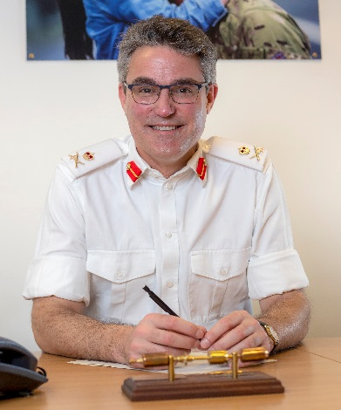
LIEUTENANT GENERAL J F P SWIFT OBE
Lieutenant General James Swift has been Chief of Defence People for the Ministry of Defence since the end of February 2020. He is responsible for the people agenda across Defence, in particular leading People Transformation and the HR function.
His previous role was General Officer Commanding of the 3rd (United Kingdom) the UK's high-readiness warfighting Division. Prior to which he was Assistant Chief of the General Staff (ACGS) where he led on corporate strategy and was the Chief of Staff of the Army. He was Head of Capability Strategy in the MOD for the Strategic Defence and Security Review in 2015. Before that he commanded 20th Armoured Brigade from 31st May 2012.
He was Colonel Army Strategy in the MOD over the period of the Strategic Defence and Security Review 2010 and the subsequent design of Army 2020. Prior to that he commanded the 2nd Battalion the Royal Welsh, which was defined by command of the Manoeuvre Battle Group on Op TELIC 10 between May and December 2007.
Other posts include: Military Assistant of the Deputy Chief of the Defence Staff (Commitments) in the MoD, officer commanding C Company of the 1st Battalion the Royal Regiment of Wales including two tours of operations in Iraq in 2003-2005, and Chief of Staff of 4th Armoured Brigade including Exercise SAIF SAREEA II in Oman.
In his early career he served in England, Germany, Northern Ireland and Hong Kong filling a variety of staff and regimental duty posts. He was commissioned into the 1st Battalion the Royal Regiment of Wales in 1990. He completed the Higher Command and Staff Course in 2011, the Advanced Command and Staff Course in 2001 and an MSc in Defence Technology in 2000. He has an MA (Oxon) in Chemistry. He was appointed MBE in 2006 and OBE in 2008.
He is married to Petra and they have two teenage boys. His interests include sailing, rugby, golf and bridge but much of his spare time is spent on various touchlines supporting his boys.

