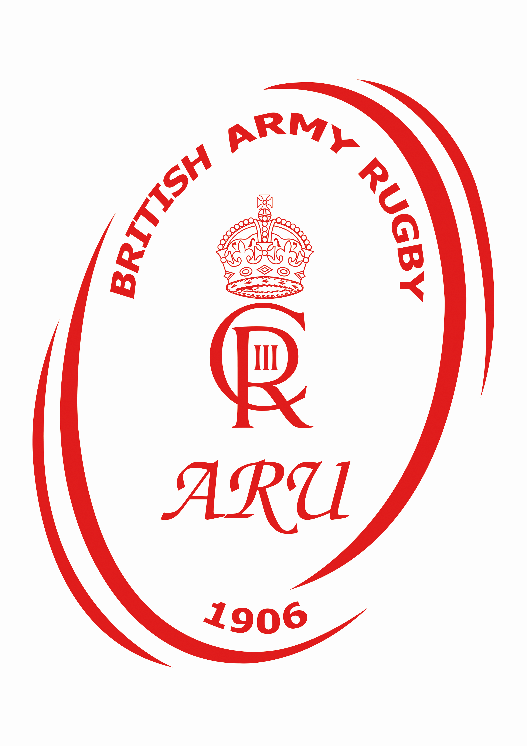

The Army Rugby Union (ARU)
Safety Management Plan (SMP)

Record of Amendments
Version | Date | Section | Detail of Amendment
1.0 | 12 Mar 21 | All | Initial Publication
1.1 | 27 Jul 21 | All | Complete review
1.2 | 13 Nov 23 | All | Complete Review

CONTENTS Page
Introduction The ARU Commitment to Total Safety – a message from the Chair 4
Chapter 1 The ARU Safety Policy 5 1.1 Scope 5
1.2 Chair’s Safety Commitment 5
1.3 The ARU’s Governance Arrangements 6
1.4 The ARU’s safety Management System 6
1.5 The ARU’s Rugby Safety Policy Hierarchy 6
Chapter 2 The ARU Rugby Safety Organisation 7 2.1 Responsible Individuals 7 2.2 Responsibilities and Organisation – The ARU 7 2.3 Training and Education 7
Chapter 3 ARU Safety Management Activities 8 3.1 Governance and Assurance 8 3.2 Risk Management and Risk Registers 8 3.3 Risk Management of ARU Rugby Activities 8 3.4 Management of Change 9 3.5 Review of the SMS 10 3.6 Reporting and Investigation of Occurrences 10 3.7 Communication 10 3.8 Security of External Events 10
Annexes:
A. Checklist for Match Organisers/Team Managers. 11
B. A Generic ARU Rugby Risk Assessment. (on the ARU web) 13
C. ARU SB 1st Party Audit - Self-Assessment Questionnaire 14

Introduction: The Army Rugby Union Rugby Commitment to Total Safety – A message from the Chair
By Brigadier James Cook OBE
The ARU is committed to providing high profile rugby events in a safe and controlled manner. I believe the safety and welfare of everyone involved, from the executive to the players on the pitch and the spectators in the stands, to be of paramount importance. We will do everything we can to make ARU events as safe as possible, while maintaining the inherent qualities of the contact sport that make rugby great. Through this plan we will make sure that safety is considered at every level of planning and delivery, and that we regularly review and adjust as necessary and appropriate our safety performance.

James Cook OBE
13 Nov 23

Chapter 1 – ARMY RUGBY UNION (ARU) SAFETY POLICY
1.1 Scope
The scope of this Safety Management System (SMS) ranges across all those who are involved in the delivery of ARU activity, it applies to all serving military personnel, foreign nationals, civilian employees, and contractors involved in ARU activities.
1.2 Chair’s Safety Commitment
The Director of Army Sport requires the Chair of the ARU to be accountable for the way in which they run and manage the organisation. The Chair ARU is required, on an annual basis, to account for their safety performance, measured against DSA 01.1 (Defence Policy for Health, Safety and Environmental Protection) criteria which, as well as underpinning all our Safety activities such as meetings and assurance visits, also form the basis for the ARU’s safety commitments. These are summarised as:
- To prevent fatalities and to minimise injury to people playing rugby union in the ARU events whilst on duty;
- To manage the ARU’s SMS;
- To comply with higher level safety regulations;
- To supervise and control ARU activities; and
- To investigate and learn from any incidents and accidents
1.3 ARU’s Governance Arrangements
1.3.1 The Policy Statement by the Secretary of State (SofS) for Defence for Health, Safety and Environmental Protection (HS&EP) applies to everyone and all organisations within Defence who conduct defence activities, including the ARU. It is a fundamental objective that the risk to the health and safety of anyone conducting or affected by defence activities is reduced as low as reasonably practicable (ALARP).
1.3.2 Overall policy for the conduct of United Kingdom Armed Forces (UKAF) Rugby rests with the UKAF Sports Board. UKAF Rugby as an approved associated, is managed by the UKAF Rugby Executive Committee, whose officials act in accordance with the governance arrangements directed by the sport’s National Governing Body (NGB); The Rugby Football Union (RFU).
1.4 The ARU Safety Management System
ARU Safety Management System in a paragraph. In order to achieve the Secretary of State’s policy outlined in DSA 01.1 (Defence Policy for Health, Safety and Environmental Protection), we require a SMS; put simply, the SMS is the ARUs approach to Safety, in terms of Policy, Organization, Activities and Performance measurement, as shown below in the diagram.
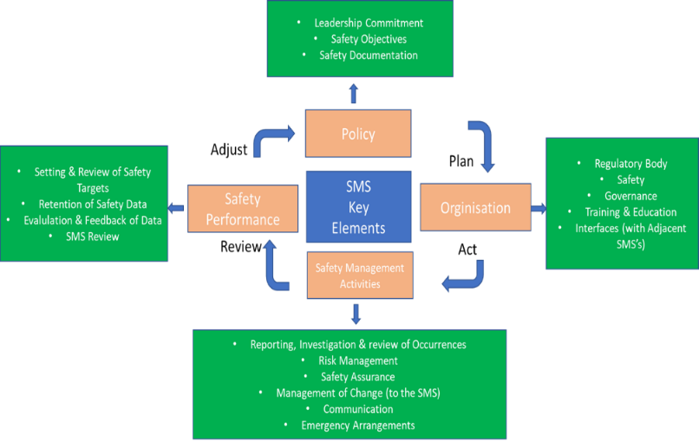

1.5 The ARU Safety Policy Hierarchy
1.5.1 The ARU delivers its output in accordance with higher level policy directives as well as internal policy determined by the Executive Committee. The following documents form the hierarchy of policy that the ARU adheres to:
- DSA 01.1 - Defence Policy for Health, Safety and Environmental Protection;
- JSP 375 - Management of Health and Safety in Defence; and
- JSP 660 - Sport in the UK Armed Forces.
1.5.2 Policy Documents. The following Joint Service Publications(JSP) form the hierarchy of policy that the ARU adheres to:
- JSP 752 (Travel Regs);
- JSP 760 (Special Leave);
- JSP 765 (Armed Forces Compensation Scheme);
- Embassy "Yellow Book";
- JSP 800 (MT Regs); Use of Supplements by Members of the Armed Forces;
- JSP 456 Vol 2, Chap 7 Def Catering Manual (CILOR).
1.5.3 The ARU will comply with the rules and regulations laid down for by both the NGB and MOD. The UKAF Sports Board is responsible for policy and provides guidance to volunteer UKAF Sporting committees.
1.5.4 The safety requirements articulated by these organisations are reflected in policy requirements of the UKAF Sports Board.

Chapter 2 THE ARU SAFETY ORGANISATION
2.1 Responsible Individuals. Defence has created a safety construct of responsible individuals to focus on the ownership and management of Risk to Life (RtL) and the accountability that arises for those specific SRAs. The ARU is considered to be an Army sport where there is a potential low RtL. Where appointed, a Responsible Individual has a personal duty of care for people who, by virtue of their involvement in activities, come within their AoR and for the public who may be affected by activities in their AoR. A Responsible Individual is accountable for ensuring that RtL from activities in their AoR are reduced to As Low As Reasonably Practicable (ALARP) and are tolerable to them. Within UKAF Sport, Single Service Heads of Sport hold the risk for the participation of their Service Personnel (SP) and they manage that risk through the chairs of their respective sports associations. Where necessary, the Chair ARU is to assure the ASCB that the risk management of the ARU sporting activity is appropriately safe for the participation of their SP.
2.1.2 The ARU Rugby Responsible Individual. The Chair of the ARU is the Responsible Individual responsible for all safety whilst personnel undertake on-duty UKAF Rugby activities.
2.1.3 The ARU Chief Operations Officer. The Chair will delegate elements of safety management to the Operations Officer who will oversee the overall match requirements for organised competitions and delegate as required to Event Staff.
2.1.4 The ARU Event Co-ordinator. The Chair will delegate elements of safety management to Event Co-ordinators who are appointed to manage the overall match requirements depending on location.
2.1.5 The Commanding Officer (CO) of each Establishment/Unit has a responsibility for the safety and duty of care for every person under their command at that location. However, when personnel from their Unit undertake authorised ARU activities at a different location, it is unreasonable and impracticable for that responsibility to extend to domains where they have no influence. Therefore, whilst undertaking authorised ARU activities, the responsibilities of safety, assessment of RtL and the duty of care is held by the ARU’s Rugby’s Responsible Individual in accordance with the fixtures agreed by the ARU Sports Board.
2.2 Responsibilities and Organisation – ARU Rugby
Our safety commitment is to strive continually to improve our safety performance and to minimise our contribution to the risk of an accident when playing Rugby Union to ALARP. To achieve this, the ARU has a clearly defined committee structure with bounded terms of reference for each post. The Terms of Reference (TOR) and responsibilities for committee members are articulated in the ARU Rugby Constitution and on the ARU website.
2.3 Training and Education
We are all required by legislation to have the necessary knowledge, experience, practical ability, and skill to perform our duties competently and safely. All personnel must understand and comply with the legislation, codes of practice, international conventions, NGB guidelines and MOD Policy required of them by their post and responsibilities within the ARU.
Chapter 3 THE ARU SAFETY MANAGEMENT ACTIVITIES
3.1 Governance and Assurance
The Responsible Individual is charged with providing assurance and safety in the ARU. This is done in several ways:
- The ARU Responsible Individual governance structure;

- Interaction between UKAF and single Service Rugby Unions to assure the appropriate safe conduct of the activity;

- For each ARU Event – completion of a Safety Checklist (Annex A) and Risk Assessment (Annex B);

- The review and analysis of ARU safety, including incidents and accidents, at an appropriate Annual General Meeting (AGM) / Executive Committee (EC) meeting; and

- Annual completion of the 1st Party Audit Self-Assessment Questionnaire issued by the ASCB at Annex C.

3.2 Risk Management and Risk Registers
3.2.1 Responsible Individuals are to identify and mitigate risks to ALARP within their AoR. The management and mitigation of safety risk is a fundamental and integral part of protecting our people whilst undertaking authorised ARU Rugby activities. They are to achieve this by pro-actively and systematically identifying hazards and assessing, then controlling, risks. The purpose is to ensure that for any ARU Rugby activity undertaken, the safety risks have been mitigated to a level judged Tolerable and ALARP.
3.2.2 All responsible individuals must ensure that their significant risks are captured. For each event systems of work, operating procedures and risk assessments will be reviewed to ensure that they remain current, and that the risks remain ALARP.
3.2.3 The ARU will use the following five steps to assess risks prevalent whilst conducting authorised activities:
- Identify the hazards;
- Decide who might be harmed and how;
- Evaluate the risks and decide whether existing control measures are adequate or whether more should be done; and
- Record the findings.

3.2.4 The Chair of the ARU has identified a low potential Risk to Life(RtL) for ARU Rugby, and when mitigations are applied, are deemed tolerable and ALARP.
3.3 Risk Management of ARU Rugby Activities
3.3.1 There are three elements to how ARU Rugby organises and delivers its business:
- Planning for the Event. The ARU Rugby Operations Officer is responsible, as directed in his/her TOR, for planning and arranging authorised ARU fixtures of significance and assuring that the appropriate safety measures are in place for the event to proceed. They will be assisted by the Event Co-ordinator. The Event Co-ordinator is to ensure that he/she has completed the safety checklist before the start of the event. This checklist is attached at Annex A. The action is to be completed in conjunction with the guidance at para 3.2 (Risk Management) below, and Annex B (Risk Mitigation Matrix);

- Delivering the Event. During this phase, the respective organisation/club hosting the event must comply with The Health and Safety at Work Act 1974 (HSWA) and all other subsequent regulations that apply to that organisation. In particular the organisation must have an appropriate Health and Safety Management System covering all of its activities that affect its members, employees, contractors, visitors and the public. The Management of Health and Safety at Work Regulations 1992 require all employers to undertake risk assessments in order to identify hazards and evaluate the risks from them to employees and any others that may be affected e.g. members and visitors to the organisation. While it is the responsibility of the organisation/club to do everything possible to protect players from risks, the players themselves, must also take measures to ensure their safety; and

- Running the Event. The ARUs Operations Officer, the Tournament Organiser or their nominated representative(s) from the EC are responsible (in the case of fixtures this may be the officially appointed Event Co-ordinator for that event) for running the event and must be in constant liaison with the organisation or club and be aware of how any potential safety issues may be identified and addressed at the earliest opportunity. The Event Organiser or Team Manager is also to ensure that any incidents are reported without delay to the ARU COO.
3.3.2 The responsible persons above will need to communicate the requirements of this policy to all participants at each event. The mechanism should be via selection letters, admin orders, or other authorisation instructions.
3.4 Management of Change
3.4.1 In the context of Safety, the management of change is primarily a risk management activity and, as such, those responsible for managing change are required to employ risk management techniques to ensure that any Safety risks associated with the change are properly understood and appropriately controlled. Particular areas of change that require careful consideration are listed below.
Tasking and Personnel Changes.
3.4.2 Impact statements must be developed which outline the risk associated with change in personnel; routine staff changes are managed through handover briefs and the setting of competencies and qualifications for the post.
Regulatory and Policy Changes.
3.4.3 New or amended regulations and policy will be promulgated by the UKAF Sports Board and UKAF Sports Secretary.
3.5 Review of the SMP. Maintaining the ARU SMP is the responsibility of the ARU COO. In the spirit of continuous improvement, this document will be reviewed formally on an annual basis and subsequent to any of the following:
- Major organisational changes within the ARU; and

- Changes in Defence regulation, specifically related to the ARU.

3.6 Reporting and Investigation of Occurrences. Reporting helps to provide the ARU with a clear and accurate understanding of our safety performance and our ability to deliver Rugby Union in a safe manner. The primary means by which this can be done is by reporting accidents to the ARU COO and any injuries reported to the UKAF / ARU Medical Director.
3.7 Communication. The Chair, via the ARU Director of Communications, is the primary focal point for all ARU rugby communications, including safety messages, to ARU Rugby members. The ARU encourages the use of a variety of media outputs to communicate Safety messaging, these include:
- Internet. The ARU website and social media pages; and

- Internal Correspondence. Targeted letters and e-mails to the EC and other key personnel. Minutes and Records of Decisions from Trustee’s and Exec Committee meetings.

3.8 Security of External Events. The ability for the public to gain access to Defence personnel or establishments during sporting events or activities can provide an opportunity for attack by those who wish to do harm. In the majority of instances, the ARU will host externally held rugby events involving elements of the public mixing with the Services, secured using existing security procedures when on MOD establishments, and personal security procedures when off MOD property. Security of external events will be considered during the event planning and included in the risk assessment. Security of external events are the remit of the Police in conjunction with the RFU and Service Police.

Annex A to
ARU SMP
Dated 13 Nov 23
ANNEX A - CHECKLIST FOR EVENT CO-ORDINATORS
Medical
1. Equipment. Location/provision of medical equipment including defibrillator, emergency vehicle access and qualified Pitch Side First Aider/Doctor.
2. Head Injury Assessment (HIA) is not routinely used at ARU games below level 2. Medical Director to assess requirement and advise.
3. Medical facilities. Location of nearest A&E Department
4. Action plan. Action on event of injury considered by medical team.
5. Player Fitness. Fitness of all players is confirmed by the Coaches and Medical staff. Medical downgrades are considered, and all players are in date for individual service fitness assessments. No players below 18 years of age.
6. Reporting. Injuries are reported to UKAF / ARU Medical Director.
Facilities
7. Pitch. Pitch is suitable for play: Inspection of pitch to include pitch markings, flags and post protectors. Pitch surrounds to be checked and cleared of debris and/or obstructions. Distance/control of spectators entering the pitch.
8. Officials. Match officials have been appointed are aware of their collective responsibility to maintain safe play. (Liaise with ARURS match appointer)
9. Entry Point / Exit Point. Entry and Exit point controls. Is there sufficient egress in event of emergency. How will it be controlled during the event. Security protocols at entrance points.
10. Parking. Parking is available such that there is not risk of Traffic build-up that would affect safety on public roads. To include traffic management into/exit parking.
11. Capacity. The event stadium has capacity for the No. of tickets sold or anticipated attendance. Social distancing requirements to be considered if appropriate.
12. Public Military Event (PME) clearance. PME clearance required? If so a 6-week lead time into regional command.
Public Health
13. Toilets. Sufficient male/female/disabled toilets for the scale of the event.
14. Social distancing. Sufficient space to allow social distancing. Consider venue capacity vs anticipated attendance.
15. Isolation/Quarantine. Effect of disease, illness spreading. Consider playing squads and spectators. How is illness transmission prevented?
16. Crowd Management. Is crowd management required? What are the arrangements and who is responsible?
Travel
17. Travel to and from fixtures must adhere to travel regulations (JSP 800 Defence Movement & Transport Requirements)
18. Fitness to travel of players after event. Accommodation and travel arrangements considered.
19. Security. ARU events are high profile public events that bring the military and public together. They are often attended by high-ranking military officers and security should be considered.
a. Direct Attack/bomb threat/terrorist activity. Action plans or incident response plans are in place. Security and policing considered. Search requirements on entry. Consider uniform and profile of high-ranking persons; and
b. Crowd Riot / Fighting. Consider numbers attending, previous issues. Stewarding and policing considerations.
20. Fire Action Plan. Does the venue host have an action plan for fire? What is the plan and is it appropriate for the ARU event?
Miscellaneous
21. Severe Weather Conditions. Are severe weather conditions forecast on the day or leading up to the event. Consider pitch condition and decision points to cancel (prior to event, before gates are open, during the event). Who makes the decision?

Annex B to
ARU SMP
Dated 13 Nov 23

MOD 510 – GENERIC RISK ASSESSMENT

A generic MOD 510 risk assessment relating to rugby is available to download via the Army Rugby Union web portal under the Health Safety and Wellbeing page –

https://www.armyrugbyunion.org.uk/game-admin/health-safety-wellbeing/

Annex C to
ARU SMP
Dated 13 Nov 23

ARU 1st PARTY ASSURANCE (SELF-ASSESSMENT) QUESTIONNAIRE
Serial | 1st Party Audit – assurance provided internally by those  responsible for delivering the output. | Check
1 | Appointment. Has the Chair of the UKAF sport association been formally appointed by the Army Sports Control Board?
2 | Association Management. Does the association have:  • A clear structure with key appointments in place?  • A management plan with a vision for future  development?  • Sound in year financial planning and a five year  funding plan?  • Conform to MOD regulations.
3 | Compliance with Safety Assurance  (Safe People, Safe Practice, Safe Equipment, Safe Place)  • Does the association have a safety management plan  (SMP) and is it reviewed annually?  • Are dynamic and generic risk assessments conducted  before activity?  • Is the SMP available to participants and are safety  briefings carried out before activity.  • Does the sport comply with NGB Rules & Regulations  (Specific to sport).  • Does the ~MOD set higher standards for the conduct  of activity? (e.g. Safeguarding for the activity and the  pastoral elements).  • Does the association have SQEP individuals (Coaches  and Officials) to supervise activity?  • Is equipment properly maintained, kept in date and  suitable for the level of activity?  • Is there a system to ensure personnel are fit to  participate?
4 | Administration.  • Is the activity or PME correctly authorised and  recorded?  • Are a detailed Administration Instruction produced for  each event or series of events?  • Are adequate first aid and medical arrangements  provided?  • Are the rules for public funding for travel and  subsistence correctly authorised and applied?  • Does the association understand the single Service  accident reporting process and adhere to it?  • Discourage substance misuse and report offenders.  • Does the association conform to MOD regulations for sponsorship and hospitality?

